GNF SymAtlas Expression Data

Overview
Novartis’ GNF SymAtlas provides experimental microarray data for human, mouse and rat tissues with a wide range of biological conditions and pathologies.
Table 1 lists all the GNF datasets currently available on GEO. These data sets include raw CEL files as well as processed expression values.
GEO | Title | Species | Platform(s)
GSE96 | 2002 GeneAtlas Data Set | Human | HG-U95A
GSE97 | 2002 GeneAtlas Data Set | Mouse | MG-U74
GSE952 | 2004 Rat GeneAtlas Data Set | Rat | RG-U34A
GSE1133 | 2004 GeneAtlas Data Set | Human | HG-U133A
GPL1073 | 2004 GeneAtlas Data Set | Mouse | GNF1M (Custom)
GPL1074 | 2004 GeneAtlas Data Set | Human | GNF1H (Custom)
GSE10246 | 2008 Mouse GeneAtlas V3 data set | Mouse | MOE430V2
Table 1: GNF datasets available on GEO

Technical Approach
The current caBIO domain model does not directly support microarray experiment data. There is a class called Anomaly (Figure 1) which documents irregularities in gene expression at a high level. Low level expression data is more appropriate for inclusion in caArray. Once analysis is done, summary data could be added to caBIO.
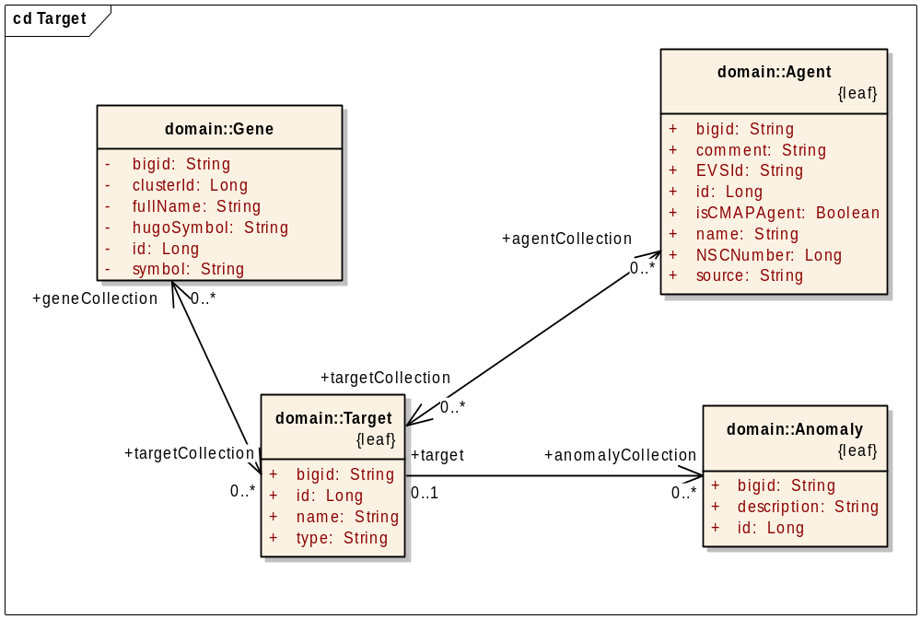
Figure 1: Current Gene Expression Model
Data may be downloaded from GEO in tab-delimited format through the use of their website or APIs.

Issues/Risks
The SymAtlas application will be retired in the future, to be replaced by the new BioGPS. This should not affect caBIO because we will be using the data alone, without relying on any frontend.

Tasks
The tasks are the same as for any new data brought into caBIO:
- Domain modeling
- Data loading

Estimated Level of Effort
If it is assumed that the data will be process and summarized in some way, roughly 2 months would be required to add the summarized data to caBIO.
Database expert – 1 month
Software Engineer – 1 month

References
SymAtlas: Supplementary Material. http://wombat.gnf.org/suppl.html
Future of SymAtlas, August 21, 2008. http://biogps.blogspot.com/2008/08/future-of-symatlas.html
Su, Andrew I., et al. Large-scale analysis of the human and mouse transcriptomes. http://www.pnas.org/content/99/7/4465.abstract

